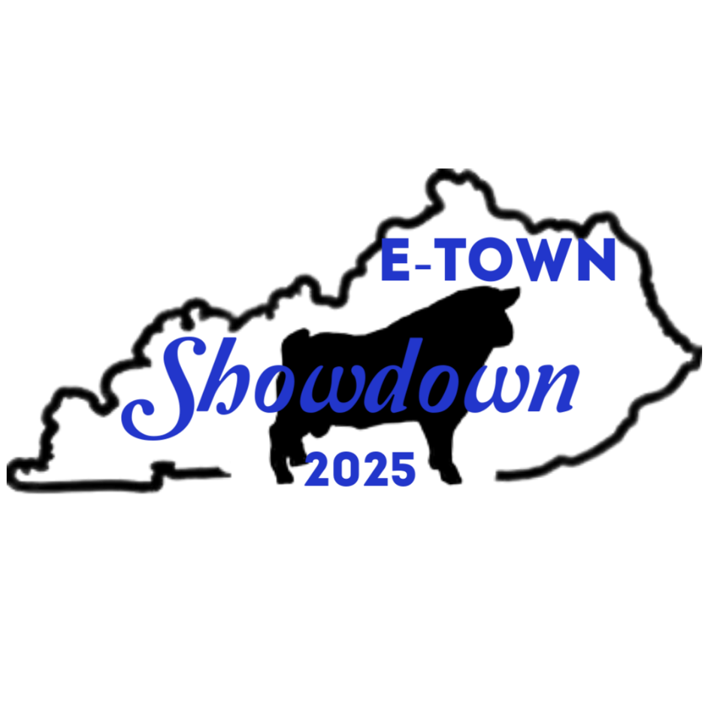

2025 E-Town Showdown Myotonic Goat Show
Horn-E-Holler Show 1, Judge James Dowell
Friday August 29, 2025 @ 5:30 pm

Head Over Heels Farm Show 2, Judge Ashley Hadley
Saturday August 30, 2025 @ 8:30 am

Turtle Creek Fainters Show 3, Judge Ben Dauer
Saturday August 30, 2025 – Immediately Following Show 2

Hardin County Cooperative Extension
111 Opportunity Way Elizabethtown, KY 42701
All shows are MGR Sanctioned with MGR Certified Judges. MGR Rules to govern and to take precedence over all others.

Goats can be checked in from 1:00 pm to 4:30pm on Friday August 29, 2025.
Additional check-in will be offered on Saturday morning before 8:00am.
There will be a lunch break, time to be specified at the show.
Notice to new exhibitors: goats registered with the herd name of a judge may not exhibit under that judge per MGR sanction rules.
- Goats must be registered by the Myotonic Goat Registry. The ORIGINAL registration certificate MUST accompany the goat during check-in. Kids under three (3) months of age must be registered for any sanctioned classes. No pending registrations will be accepted at check-in.
- Age eligibility for classes will be determined by date of birth on the registration certificate.
- The full correct registered name of goat must be used on the entry forms.
- The goats permanent ID (USDA scrapie tag, tattoo, or microchip) must be on the Health Certificate and registration from the MGR.
- The correct Breeder/Exhibitor name as on the Reg. Certificate must be on the entry form, unless you have a signed transfer application that is dated 45 days or less to the show date.
- All goats MUST have a health certificate not dated before August 10th and the show address must be your destination. Scrapie rules apply. If you use microchips, you must furnish a reader. Tattoos MUST be legible. Scrapie tags are acceptable. You MUST bring an extra copy of your goat's health certificate that will be retained by the show secretary.
- All goats must be shown with a collar. Bucks must always be secure.
- The show secretary reserves the right to split large classes.
- Entry fee: $8.00 per goat/ per show including kids in sanctioned classes.
- Entries must be received no later than August 24th to be in the show book, entries will be accepted up until the start of
the show as long as they are listed on your health certificate. There will be a late charge on entries not received by August 24th
of $2 additional per goat per class totaling $10 per goat/per show. There will be no exceptions to this rule so please
submit your entries early or plan to pay extra!
- MGR Rules to govern and to take precedence over all others.
- No refunds of entry fees under any circumstances.
- This is a ribbon and points show. Any available awards will be announced.
- Goats may be sold by private treaty. Any goats sold must be entered in the show, however, there will be a select number of sale pens available, and these goats do not need to be entered in the show. Please contact the secretary for availability before paying for entries. These goats will need to be on the health certificate as well.
- Any item that comes up that is not specifically covered by these rules will be decided by the show committee and their decision will be final. Upon no circumstances should judges be interrupted during their time judging the show.
- All exhibition goats must meet all health requirements for exhibition in Kentucky. Goats may be examined on grounds by show personnel or state Veterinarian. Goats showing evidence of disease, particularly foot rot, sore mouth, abscesses will not be allowed to enter the barn or show and may be released by officials.
- No animal with an open wound shall be allowed to be unloaded on the showground. The organizers of this show and the facility will not be liable for any loss, damage or accidents to animals, persons or property while at the show grounds. Youth exhibitors are to be accompanied by a responsible adult.
- No alcoholic beverages or smoking in the barns or arena allowed.
- Good Sportsmanship is always expected. Upon no circumstances should judges be interrupted during their time judging the show.
- Shavings may be used and purchased for $7 per bag, 1 bag will cover each pen, and MUST be pre-ordered with your entry form. You are welcome to bring your own as well.
- Pens are $10 ea. for the duration of the weekend.
- Entry fees are due at time of entry, NO EXCEPTIONS!
- Exhibitors are expected to be ringside when their class is called, if exhibitors are not present the show will go on and there are no refunds.

E-Town Showdown Myotonic Goat Show
T-Shirt Sponsorship order form.
To sponsor and get your name on the shirt the cost is $30 and comes with 1 shirt, or $40 for 2 shirts.
Additional shirts after this are $15 ea.
Youth Sizes Available (ym is 10-12, yl is 14-16)
2XL and 3XL Shirts cost an additional $2.50 ea.
Hoodies are also available for $40, $2.50 extra for 2X and 3X

Shirt orders are due no later than August 3, 2025, for your farm to be listed on the shirt as a sponsor to ensure we get the order back in time for the show.
QTY | Farm Name as desired on shirt | Size  (S, M, L, Xl, 2XL, 3XL) | Price | Total Due

If you are unable to pick your order up at the show, we can ship it to you for an additional charge of $9 to cover the cost of shipping. If ordering 3 or more shirts, contact us for a shipping quote.
When using checks and physical forms, please make all checks payable to - Antonice Thomas 234 Ferguson Lane Central City, KY 42330
When Submitting Via Email; please email to Terin McAllister - hourglassacres@yahoo.com
Electronic Payments via PayPal – ajlivestock77@gmail.com

Separate from the shirts, we will also be accepting prize sponsors:

Buck Prizes $75
Doe Prizes $75
Market Wether $75
Youth Prize Sponsors $100

Horn-E-Holler Show 1, Judge James Dowell - Friday August 29, 2025 @ 5:30 pm
Head Over Heels Farm Show 2, Judge Ashley Hadley - Saturday August 30, 2025 @ 8:30 am
Turtle Creek Fainters Show 3, Judge Ben Dauer - Saturday August 30, 2025 – Immediately Following Show 2
Exhibitor Name: _______________________________________________________ Exhibitor MGR#:________________
Address: ______________________________________________________________________________________________
Email Address: __________________________________________________ Telephone Number: ___________________
Show 1  Place an “X” for Show Participation | Show 2 | Show 3 | Goats Registered Name | Sex  B, D, PW, MW | Date of Birth | MGR Registration Number | Permanent Tattoo, Tag or Microchip | Class Number
All goats brought into the facility must be ENTERED in at least 1 of the shows except for pre-approved sales pens.
# OF MGR REGISTERED GOATS___ $8.00 PER GOAT/PER CLASS IN SHOW 1=$______
# OF MGR REGISTERED GOATS___ $8.00 PER GOAT/PER CLASS IN SHOW 2=$______
# OF MGR REGISTERED GOATS___ $8.00 PER GOAT/PER CLASS IN SHOW 3=$______

# OF SALE PENS ________$15 PER PEN TOTAL: $________
# OF SHOW/TACK PENS________$10 PER PEN TOTAL: $_______
# OF SHAVINGS_________$7 PER BAG (1 BAG COVERS 1 PEN) TOTAL: $_______

GRAND TOTAL: $__________

Checks and physical forms, please make all checks payable to - Antonice Thomas 234 Ferguson Lane Central City, KY 42330, When Submitting Via Email; please email to Terin McAllister - hourglassacres@yahoo.com, Electronic Payments via PayPal – ajlivestock77@gmail.com
Statement of liability: The Show Management will not be responsible for any loss or damage that may occur. Each exhibitor will be solely responsible for their own liabilities, if incurred, as well as damage or injury to any other person or property caused by the exhibitor or animals they exhibit.
Entry Form for Showmanship - Bucks may not be used in showmanship

Exhibitor 1

Showmanship Exhibitor Name: ______________________________ Exhibitor Youth MGR #: ______________
Address: ______________________________________________________________________________________
Phone Number: _______________________________ Email: __________________________________
Showmanship Exhibitor Date of Birth: _______________

Show 1  Place an “X” for Show Participation | Show 2 | Show 3 | Goats Registered Name | Sex  D, PW, MW | Date of Birth | MGR Registration Number | Permanent Tattoo, Tag or Microchip | Class Number

Exhibitor 2

Showmanship Exhibitor Name: ______________________________ Exhibitor Youth MGR #: ______________
Address: ______________________________________________________________________________________
Phone Number: _______________________________ Email: __________________________________
Showmanship Exhibitor Date of Birth: _______________

Show 1  Place an “X” for Show Participation | Show 2 | Show 3 | Goats Registered Name | Sex  D, PW, MW | Date of Birth | MGR Registration Number | Permanent Tattoo, Tag or Microchip | Class Number

Exhibitor 3

Showmanship Exhibitor Name: ______________________________ Exhibitor Youth MGR #: ______________
Address: ______________________________________________________________________________________
Phone Number: _______________________________ Email: __________________________________
Showmanship Exhibitor Date of Birth: _______________

Show 1  Place an “X” for Show Participation | Show 2 | Show 3 | Goats Registered Name | Sex  D, PW, MW | Date of Birth | MGR Registration Number | Permanent Tattoo, Tag or Microchip | Class Number

Exhibitor 4

Showmanship Exhibitor Name: ______________________________ Exhibitor Youth MGR #: ______________
Address: ______________________________________________________________________________________
Phone Number: _______________________________ Email: __________________________________
Showmanship Exhibitor Date of Birth: _______________

Show 1 | Show 2  Place an “X” for Show Participation | Show 3 | Goats Registered Name | Sex  D, PW, MW | Date of Birth | MGR Registration Number | Permanent Tattoo, Tag or Microchip | Class Number
Goat must have a health certificate. Statement of liability: The Show Management will not be responsible for any loss or damage that may occur. Each exhibitor will be solely responsible for their own liabilities, if incurred, as well as damage or injury to any other person or property caused by the exhibitor or animals they exhibit.

Horn-E-Holler Show 1, Judge James Dowell - Friday August 29, 2025 @ 5:30 pm
Head Over Heels Farm Show 2, Judge Ashley Hadley - Saturday August 30, 2025 @ 8:30 am
Turtle Creek Fainters Show 3, Judge Ben Dauer - Saturday August 30, 2025 – Immediately Following Show 2
MGR Rules to govern and to take precedence over all others.

Start time promptly at 5:30pm for Show 1
Start time promptly at 8:30am for Show 2
Show 3 to start ASAP after show 2
Showmanship

- Pee-Wee Showmanship (Free to all Jr. Breeders under 6yrs)
- Youth Junior Showmanship (Free to Jr. Breeders, 6yrs – 9 yrs)
- Youth Jr. High Showmanship (Free to Jr. Breeders, 10 yrs-14 yrs)
- Youth Senior Showmanship (Free to Jr. Breeders, 15 yrs – 18 yrs)
(Classes 1, 2, 3, 4 are open only to MGR Youth Breeders)
Doe Show - Junior Does

- Pee Wee Doe Kids: 0 to 3 months of age
- Doe Kids: 3 to 6 months of age
- Junior Doe Kids: 6 to 9 months of age
- Intermediate. Doe Kids: 9 to 12 months of age
- Yearling Doe - Jr. Unfreshened: 12 to 18 months of age
- Yearling Doe - Jr. Unfreshened: 18 to 24 months of age
Junior Champion & Reserve Junior Champion Doe

Doe Show - Senior Does
- Yearling Doe -Sr. Freshened: 12 to 18 months of age
- Yearling Doe -Sr. Freshened: 18 to 24 months of age
- Junior Adult Does: 24 to 36 months of age
- Does: 36 to 48 months of age
- Senior Does: 48 to 60 months of age
- Senior Does: 60months of age and older
Senior Champion & Reserve Senior Champion Doe
Overall Grand Champion & Reserve Grand Champion Doe

Buck Show - Junior Bucks

- Pee Wee Buck Kids: 0 to 3 months of age
- Junior Buck Kids: 3 to 6 months of age
- Intermediate Buck Kids: 6 to 9 months of age
- Senior Buck Kids: 9 to 12 months of age
Junior Champion & Reserve Junior Champion Buck
Buck Show - Senior Bucks
- Yearling Bucks: 12 to 18 months of age
- Yearling Bucks: 18 to 24 months of age
- Junior Adult Bucks: 24 to 36 months of age
- Adult Bucks: 36 to 48 months of age
- Senior Bucks: 48 to 60months of age
- Senior Bucks: 60 months of age and older
Senior Champion & Reserve Senior Champion Buck
Overall Grand Champion & Reserve Grand Champion Buck

Platinum Wether Show - Junior Wethers
- Pee Wee Wether Kids: 0 to 3 months of age
- Junior Wether Kids: 3 to 6 months of age
- Intermediate Wether Kids: 6 to 9 months of age
- Senior Wether Kids: 9 to 12 months of age
Junior Champion & Reserve Junior Champion Wether
Platinum Wether Show - Senior Wethers
- Intermediate Senior Wether: 12 to 18 months of age
- Intermediate Senior Wether: 18 to 24 months of age
- Adult Wether: 24 to 36 months of age
- Senior Wether: 36 months of age and over
Senior Champion & Reserve Senior Champion Wether
Overall Grand Champion & Reserve Grand Champion Wether

Market Wether Show
Wether Show – Light-Weight Market Wethers

- Light Weight Wether: 0 to 3 months of age
- Light Weight Wether: 3 to 6 months of age

Champion Light -Weight & Reserve Champion Light -Weight Wether
Wether Show – Heavy-Weight Market Wethers

- Heavy-Weight Market Wether: 6-9 months of age
- Heavy-Weight Market Wether: 9-12 months of age
Champion Heavy-Weight & Reserve Champion Heavy-Weight Wether
Overall Grand Champion Market & Reserve Grand Champion Market Wether

